Change Password — Admin Account Takeover
Proof of Concept Report — HackViser Lab
Prepared by: Aakash Singh | Date: May 31, 2026

Vulnerability Information

Author | Aakash Singh
Date | May 31, 2026
Lab | Change Password — Admin Account Takeover
Platform | HackViser
Vulnerability Type | Broken Access Control / IDOR in Password Reset
Severity | Critical
CWE | CWE-639
Impact
An attacker can intercept and modify the password change request to change another user's (or admin's) password without authorization, leading to full account takeover.
Reproduction Steps
Step 1: Log in as a regular user and navigate to the password change / forgot password feature.
Step 2: Initiate the password change flow and capture the outgoing request in Burp Suite.
Step 3: Observe the request contains a user ID parameter (e.g., user=2).
Step 4: Modify the user ID from 2 to 1 (admin user) in Burp Repeater.
Step 5: Forward the modified request — admin password is changed to the attacker-controlled value.
Step 6: Log in with the admin credentials using the newly set password.
Step 7: Retrieve the CTF flag token from the admin dashboard.
Step 8: Full admin account takeover confirmed.
Evidence Screenshots
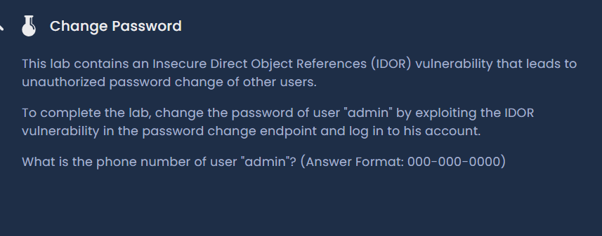
Figure 1: User login — initiating password change flow
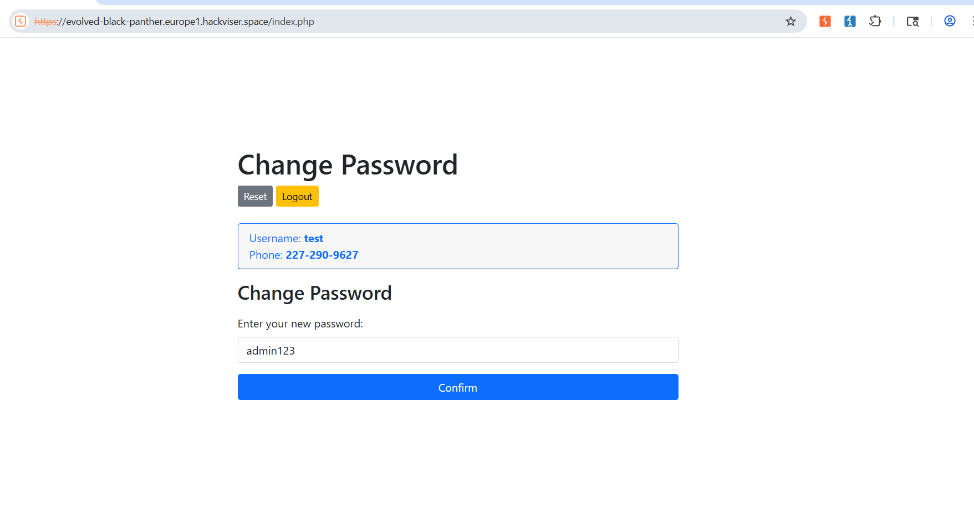
Figure 2: Password change request captured in Burp Suite
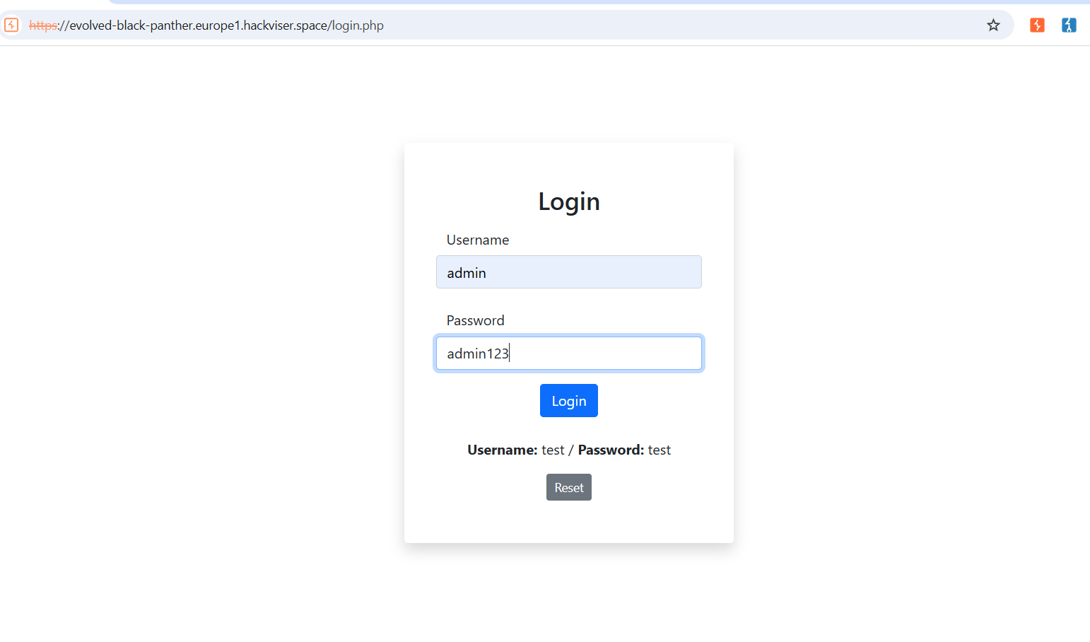
Figure 3: Admin account login page
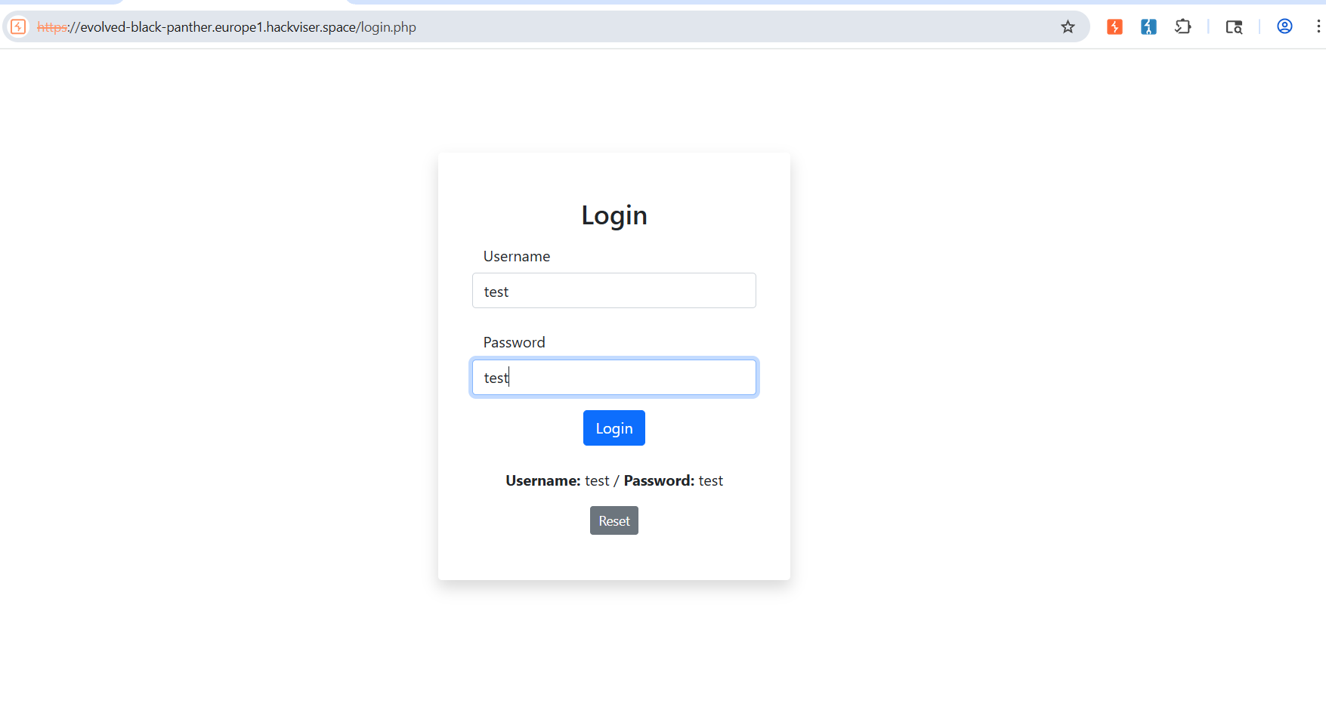
Figure 4: Regular user login confirmation
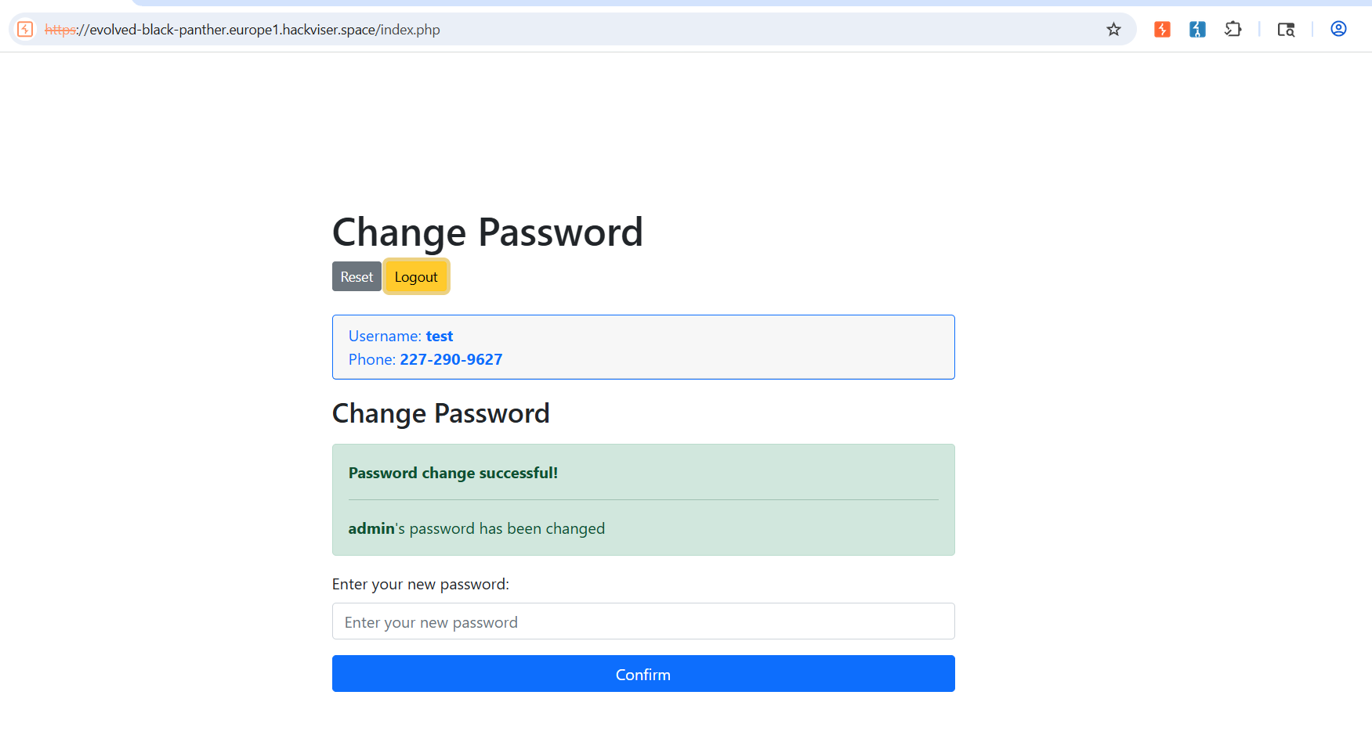
Figure 5: Password change request — original user parameter
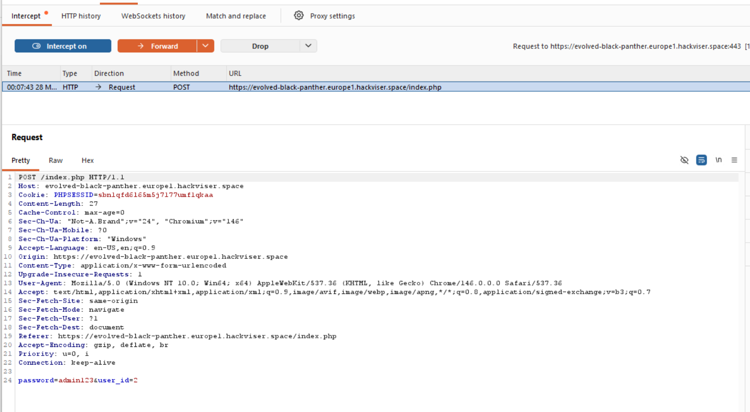
Figure 6: Request modified — user ID changed from 2 to 1 (admin)
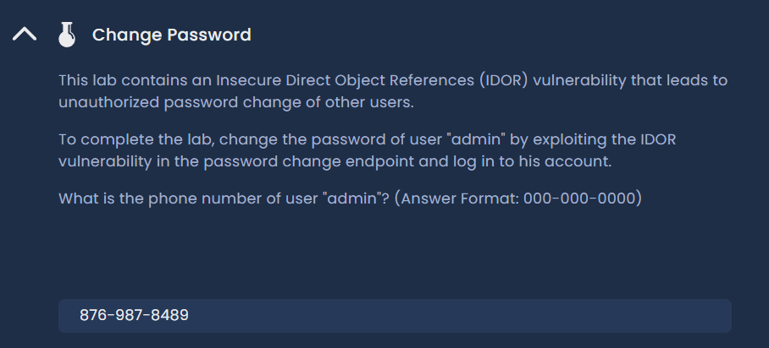
Figure 7: CTF flag token retrieved
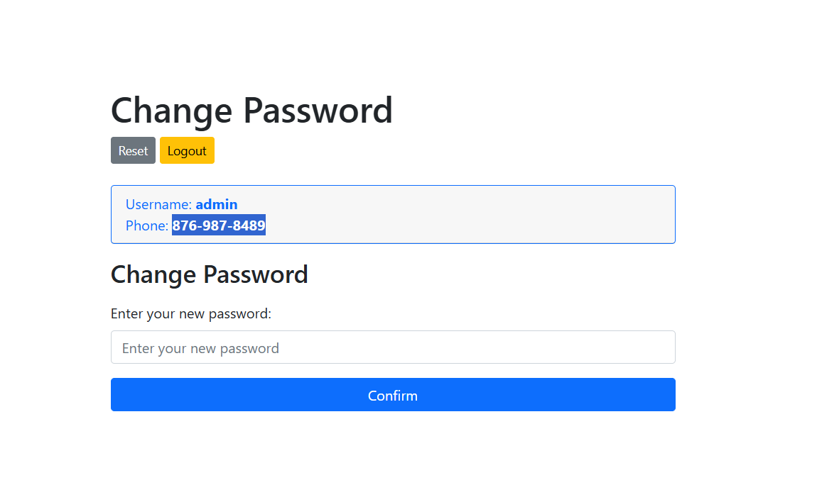
Figure 8: Admin account takeover confirmed
Remediation
Validate that the requesting user owns the account being modified. Bind password change operations to the authenticated session, not to a user ID parameter in the request.
Confidential — Prepared by Aakash Singh | Security Research POC

